Kunal babar
Course- GDSP batch 5
- Creating databaSse create database library_;
- Changing the current database Use library_;
- Creating the PUBLISHER table /*creating PUBLISHER table*/ create table publisher(
publisher_name varchar (10) primary key,address varchar (20),phone bigint(10));
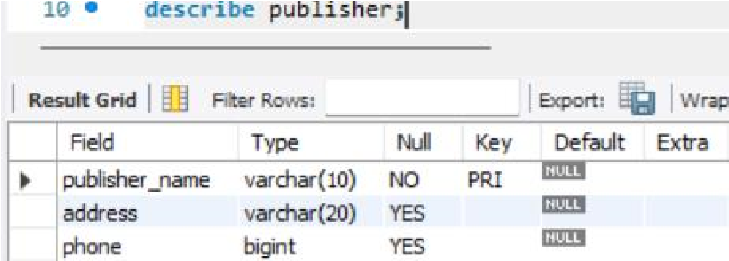
- Creating the BOOK table where foreign key is used once /*creating BOOK table*/ create table book( book_id varchar (10) primary key,title varchar (10),publisher_name varchar (10), foreign key(publisher_name) references publisher(publisher_name));
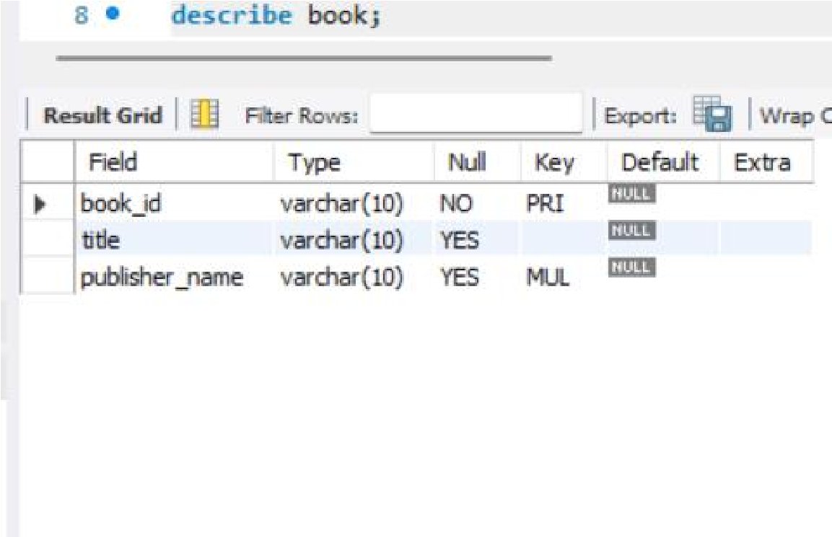
- Creating the LIBRARY BRANCH table create table library_branch(
branch_id varchar (10) primary key,branch_name varchar (10),address varchar (10));
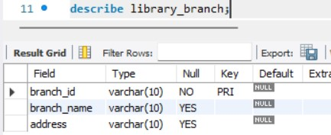
- Creating the BORROWER table /*creating BORROWER table*/ create table borrower(
card_no varchar (16) primary key,borrower_name varchar(10),address varchar (20),phone bigint(10));
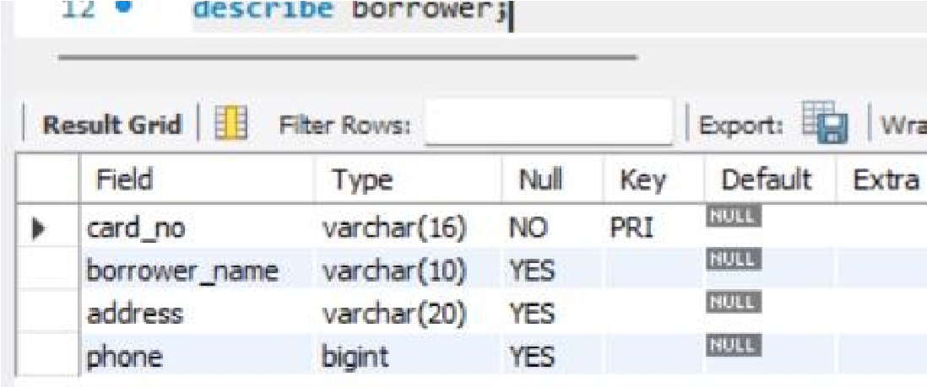
- Creating BOOK LOANS table where foreign key is used thrice /*creating BOOK_LOANS table*/ create table book_loans(
book_id varchar (10) primary key,branch_id varchar (10),card_no varchar(16),dateout date,datein date,
foreign key(book_id) references book(book_id), foreign key(branch_id) references library_branch(branch_id), foreign key(card_no) references borrower(card_no));
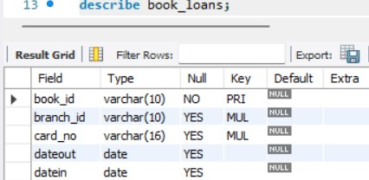
- Creating BOOK AUTHOR table where foreign key is used once /*creating BOOK_AUTHOR table*/
create table book_author(
book_id varchar(10) primary key,authorname varchar(10), foreign key(book_id) references book(book_id));
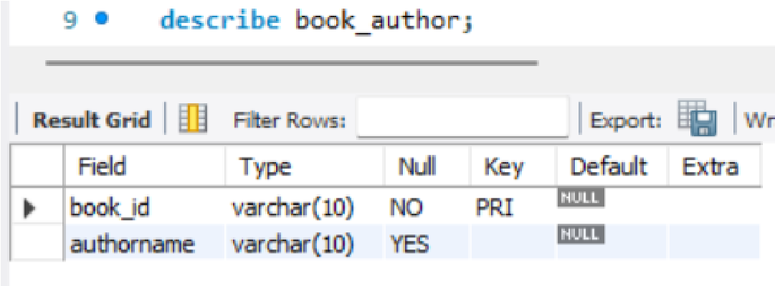
- Creating BOOK COPIES table where foreign key is used twice /*creating BOOK_COPIES table*/ create table book_copies(
book_id varchar(10) primary key,branch_id varchar (10),no_of_copies bigint(10), foreign key(book_id) references book(book_id), foreign key(branch_id) references library_branch(branch_id));
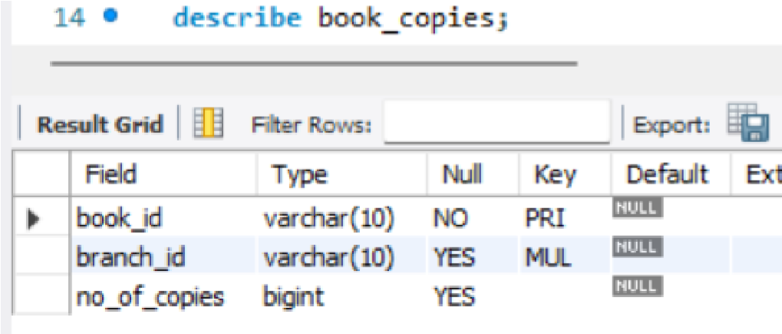
- Showing all the tables
Show tables;
